

Watch the story, “Jacob and Rachel” on the RidgeKids Teays Valley Facebook group.

Videos are posted on Facebook every Monday.

**Prayer:** Pray about something you need to trust God for in your future. Ask God to protect you and take care of you. Amen.

**Read the story “Jacob and Rachel”**

K-3rd: Read page Genesis 29:16-30

**Answer the following questions True or False.**

_____ Laban had two daughters, Rachel and Leah.

_____ Leah was the most beautiful of the two sisters.

_____ Jacob wanted to marry Rachel.

_____ Laban told Jacob to work 7 years and he could marry Rachel.

_____ After 7 years, Laban gave Rachel to marry Jacob.

_____ Laban tricked Jacob into marrying Leah.

_____ Jacob had to work 14 more years.

**Prayer:** Dear God, help me to remember that your plans happen no matter what. Even if someone tries to trick me, I can still trust your plan. Amen.



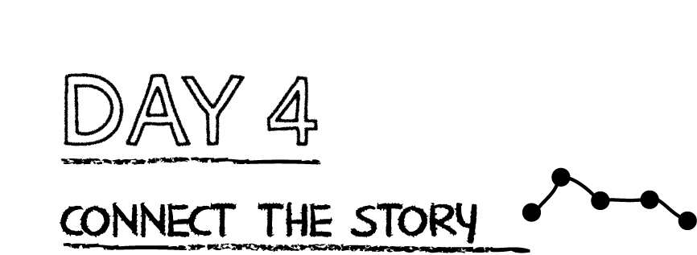

**Practice the key passage by filling in the missing words from Genesis 28:15 CLB.**

“Look, I am ________________________ you and will _________________ over you

___________________ you go. I will ___________________ you back to this land, for I

will not ____________________ you until I have done what I have promised you.”

**Prayer:** Dear God, help me to remember that you are with me wherever I go. Amen.

*.*

**Nothing could stop God’s plan for the family of Abraham, Isaac, and Jacob. Even though Jacob did not love Leah, God loved her and used her in His plan. Through the family of Jacob and Leah’s son Judah, God would show His love for the world by sending His Son to be the Savior He promised.**

What can stop God’s plans?______________________________________________

**Read Proverbs 19:21**. What do you learn about God’s plans?

__________________________________________________________________________

__________________________________________________________________________

**Prayer:** God, thank you that you have a set plan for my life and for every single person. Help me to remember that I can trust your plan. Amen.