

**Place the following events in order by numbering the statements 1-5.**

______ Jesus was taken to the high priest and then to the Roman governor.

______ Jesus was beaten and nailed to a cross with a crown of thorns on his head.

______ Jesus took his disciples to the garden called Gethsemane and spent some time praying there.

______ Judas arrived with a large crowd carrying swords and clubs. Judas stepped up and kissed Jesus on the cheek.

____Jesus died and was buried in a tomb. Three days later, the stone was rolled away and Jesus was risen!

**Read the story “Crucifixion and Resurrection”**

K/1st grade: Read page 256 of the Big Picture Interactive Storybook Bible

2nd grade: Matthew 26:36–28 of the Big Picture Interactive Bible

Watch the story, “Crucifixion and Resurrection” on the RidgeKids Teays Valley Facebook group.

Videos are posted on Facebook every Monday.

**Prayer:** Dear Jesus, thank you so much that you died on the cross to pay for my sins. I am so sorry for my sin. I could never work enough to pay for my sin. Only through your death can I find forgiveness. Amen.

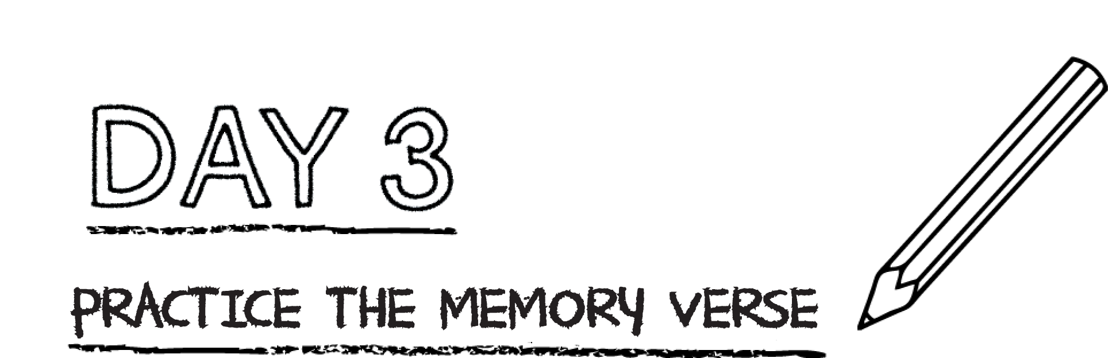



**Fill in the missing words from the memory verse. (Galatians 2:20 CSB)**

I have been ________________ with Christ, and I no longer ________________, but

__________________ lives in me. The _________________ I live in the body, I live by

____________________ in the Son of God, who ____________________ me and

__________________ himself up for me.

**Word Bank**: Crucified Christ loved live

life faith gave

**Prayer:** Dear God, thank you that you gave your life up for me!

*.*

The crucifixion and resurrection of Jesus is the center of the gospel. We deserve to die because of our sin, but Jesus died in our place. He was the blood sacrifice made once and for all for the forgiveness of sin. God was pleased with Jesus’ sacrifice and raised Jesus from the dead to reign as King over all creation. We are forgiven only through Jesus.

**Finish the sentences to create your own prayer of thanksgiving.**

Dear Jesus, Thank you that you died on the cross to forgive me of my sins. This week, I sinned when I **_____________________________________________________________________________**

**_____________________________________________________________________________**

I could never pay for my sin on my own because I sin every single day. Help me to live for you. Help me to be _____________________________________________________

_______________________________________________________________________ . Amen.