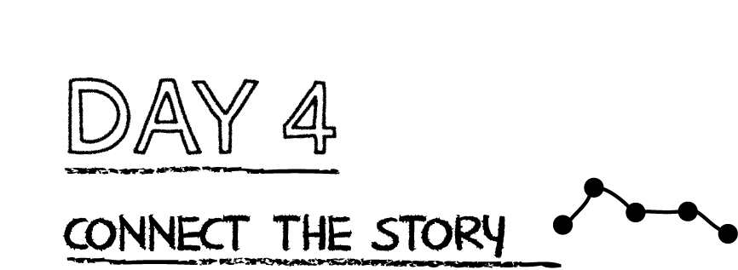

The church leaders met in Jerusalem to answer a tough question: Can a person be saved by faith alone or was something more needed? The early church agreed that because of Jesus; death and resurrection, He alone is all we need to be saved.

What kinds of things do we sometimes think we need to do in addition to having faith in Jesus? _________________________________________________________________________________

**Read John Ephesians 2:8-9.** Fill in the blanks: “For you are saved by _____________ through _________________, and this is not from yourselves; it is God’s ________________-----not from ___________________ , so that no one can boast.

**Prayer:** God, Thank you so much that we are saved by Christ alone. We could never work hard enough or do enough good things to earn salvation. Thank you that you died on the cross to pay for my sins. Amen.

**Read John 14:6**

**What is your favorite part of the verse?________________________________________**

**_____________________________________________________________________________**

**How can you apply this verse to your life?_____________________________________**

**_____________________________________________________________________________**

**Write a prayer about this verse to God:** _______________________________________

_____________________________________________________________________________

_____________________________________________________________________________

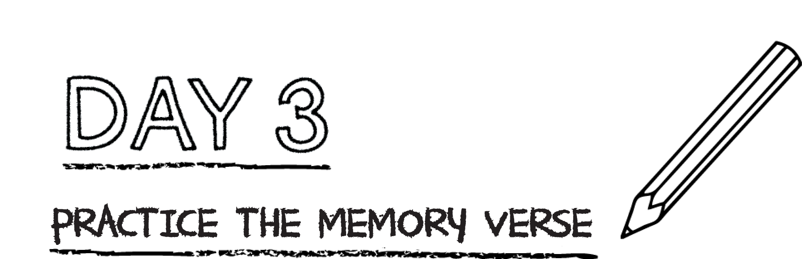



**Practice the memory verse by placing an “X” over any words that are incorrect. Then write the correct word over top. (Hint: there are 4)**

“But you will receive fear when the Holy Spirit has come upon you and

you will be my friends in Jerusalem, in all Judea and Samaria and to the

beginning of the state.”

**Prayer:** Dear God, thank you so much that you give us power to be your witnesses. Help me to be your witness to my friends, family and community. Amen.

*.*

**Read Romans 10:9**

**What is your favorite part of the verse?________________________________________**

**_____________________________________________________________________________**

**How can you apply this verse to your life?_____________________________________**

**_____________________________________________________________________________**

**Write a prayer about this verse to God:** _______________________________________

_____________________________________________________________________________

_____________________________________________________________________________