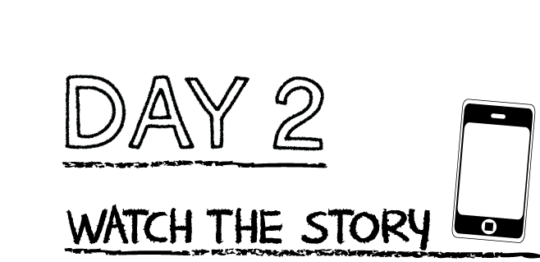

**Draw a line from the question on the left to the correct answer on the right.**

Who was not with the disciples when Jesus came? The mark of the nails

What did the other disciples kept telling him? “My Lord and my God!”

What did he say he would need to see to believe? Thomas

What did Jesus say when he appeared to Thomas? “We have seen the Lord.”

What did Thomas say in response to Jesus? “Put your finger here and

observe my hands. Reach

out your hand and put it

into my side. Don’t be an

unbeliever, but a believer.”

Watch the story, “Jesus and the Doubter” on the RidgeKids Teays Valley Facebook group.

Videos are posted on Facebook every Monday.

**Read the story “Jesus and the Doubter”**

K/1st grade: Read page 260 of the Big Picture Interactive Storybook Bible

2nd-5th grade: John 20:24-29 of the Big Picture Interactive Bible

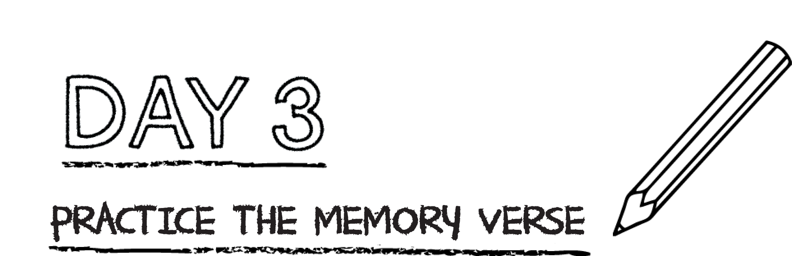

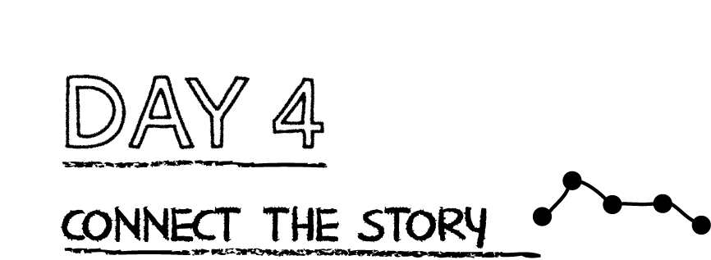

**K-3rd-Practice the memory verse by singing and dancing at home. Make a video of yourself singing the song and post it “RidgeKids Teays Valley” Facebook group.**

**4th-5th: Mark an “X” over the incorrect words from the verse listed below. Then write the correct words above the “X.” (Hint: there are 5 errors)**

For I passed on to you as most important what I also received:

that Christ fought for our sins according to legend,

that He was hidden, that He was raised on the 30th day

according to the scriptures, and that He appeared to Cephas,

then to the army.

*.*

Thomas saw Jesus for himself. He saw that Jesus had been raised from the dead and

was alive. He saw Jesus’ scars from the cross, where Jesus died for our sins. We have

not seen Jesus, but Jesus said if we believe in Him without seeing Him, we are blessed.

**Complete the following sentences to make a personal prayer to God.**

Dear God, sometimes it is hard to believe you because ________________________

____________________________________________________________________________.

I want to believe you. Help me to believe who you say you are. Help me to

believe you even when I feel ______________________________________. Amen.