

**Place the following events in order by numbering the statements 1-5.**

____ Moses sent spies to the land of Canaan.

____ Caleb, one of the spies, wanted to take possession of the land, but the other men were afraid that the people would be stronger than them.

____ The spies reported that the land was flowing with milk and honey.

____ Only Joshua and Caleb were permitted to enter the land and remained alive.

____ The spies traveled throughout the land for 40 days.

**Prayer:** Lord, help me to trust you even when I am scared like Joshua and Caleb did. Amen.

**Read the story “Joshua and Caleb”**

K-1st grade: Read page 42 of the Big Picture Interactive Storybook Bible (The last 3 paragraphs)

2nd-3rd grade: Read Numbers 13:1-2, 21-25, 30. 36-38

Watch the story, “Joshua and Caleb” on the RidgeKids Teays Valley Facebook group.

Videos are posted on Facebook every Sunday through RidgeKids Online.

**Prayer:** Dear God, thank you for not punishing me even when I deserve it. Help me to trust in you and your plans for my life. Amen.

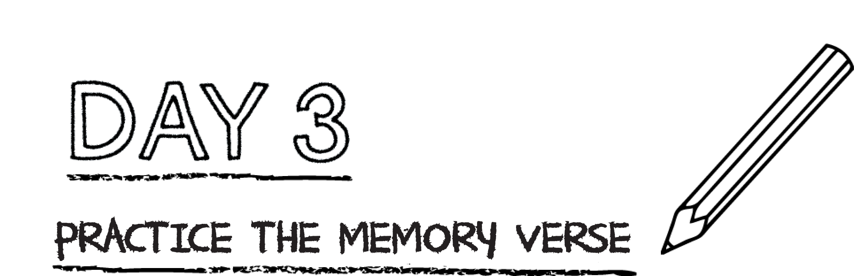



**The Israelites rebelled against God because they did not trust Him. Jesus trusted God**

**perfectly. He took the punishment we deserve for our sin, or rebellion against God.**

**When we trust in Jesus, God forgives our sin and gives us eternal life.**

Read Mark 9:24. What did the boy’s father ask Jesus to help him overcome? _____

_______________________________________________________________________________

**Complete the following prayer:**

Dear God,

I do believe in you. But sometimes I still have doubt or unbelief. Help me when I doubt ___________________________________ or ___________________________________.

Help me to overcome my unbelief and grow in my faith. Amen.

**Practice the memory verse by writing it.**

**(K/1st write “Trust the Lord with all your heart.)**

Trust in the Lord with all your heart, and do not rely on your own understanding; think about Him in all your ways, and He will guide you on the right paths. Proverbs 3:5-6

**Pray:** Lord, help me to trust you and rely on you and not myself. Amen.

*.*